Document retrieval from Wikipedia data

Summary / Observations:
Tasks:
- Built Nearest Neighbor models with different input features and setting distance Metric
- Gained intuition for different notions of similarity and practice finding similar documents.
- Explored the trade-offs with representing documents using raw word counts and TF-IDF
- Explored the behavior of different distance metrics by looking at the Wikipedia pages most similar to President Obama’s page.
Visualizations:
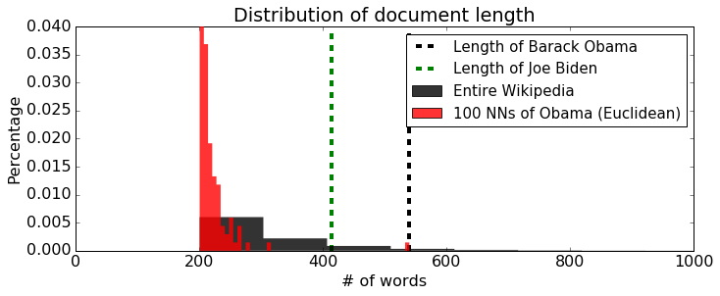
Relative to the rest of Wikipedia, nearest neighbors of Obama are overwhelmingly short, most of them being shorter than 300 words. The bias towards short articles is not appropriate in this application as there is really no reason to favor short articles over long articles (they are all Wikipedia articles, after all). Many of the Wikipedia articles are 300 words or more, and both Obama and Biden are over 300 words long.
Note: For the interest of computation time, the data set given here contains excerpts of the articles rather than full text. For instance, the actual Wikipedia article about Obama is around 25000 words. Do not be surprised by the low numbers shown in the histogram.
Note: Both word-count features and TF-IDF are proportional to word frequencies. While TF-IDF penalizes very common words, longer articles tend to have longer TF-IDF vectors simply because they have more words in them.
To remove this bias, we turn to cosine distances:
Cosine distances let us compare word distributions of two articles of varying lengths.
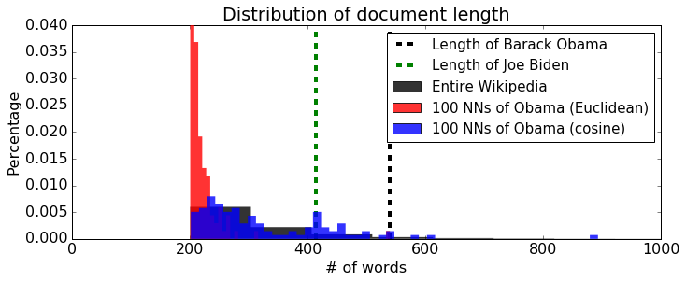
Indeed, the 100 nearest neighbors using cosine distance provide a sampling across the range of document lengths, rather than just short articles like Euclidean distance provided.
Moral of the story: In deciding the features and distance measures, check if they produce results that make sense for your particular application.

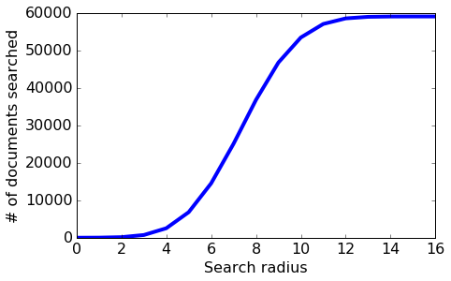
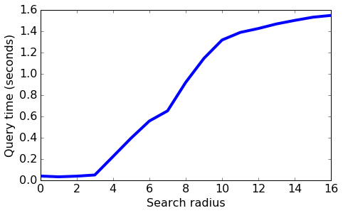
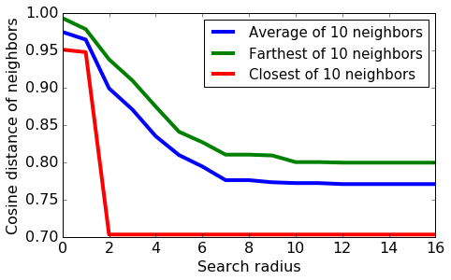
Some observations:
- As we increase the search radius, we find more neighbors that are a smaller distance away.
- With increased search radius comes a greater number documents that have to be searched. Query time is higher as a consequence.
- With sufficiently high search radius, the results of LSH begin to resemble the results of brute-force search.
Detailed Observations:
- Nearest neighbours with raw word counts got some things right, showing all politicians in the query result, but missed finer and important details.
- Much of the perceived commonalities between Obama and Barrio were due to occurrences of extremely frequent words, such as "the", "and", and "his". So nearest neighbours is recommending plausible results sometimes for the wrong reasons.
- To retrieve articles that are more relevant, we should focus more on rare words that don't happen in every article. TF-IDF (term frequency–inverse document frequency) is a feature representation that penalizes words that are too common. Let's use GraphLab Create's implementation of TF-IDF and repeat the search for the 10 nearest neighbours of Barack Obama:
- Noticed the huge difference in this calculation using TF-IDF scores instead of raw word counts. We've eliminated noise arising from extremely common words.
- Note: For the interest of computation time, the dataset given here contains excerpts of the articles rather than full text. For instance, the actual Wikipedia article about Obama is around 25000 words. Do not be surprised by the low numbers shown in the histogram.
- Note: Both word-count features and TF-IDF are proportional to word frequencies. While TF-IDF penalizes very common words, longer articles tend to have longer TF-IDF vectors simply because they have more words in them.
- To remove this bias, we turn to cosine distances:
- d(x,y)=1−xTy∥x∥∥y∥
  - Cosine distances let us compare word distributions of two articles of varying lengths.
  - Let us train a new nearest neighbour model, this time with cosine distances. We then repeat the search for Obama's 100 nearest neighbors.
- Moral of the story: In deciding the features and distance measures, check if they produce results that make sense for your particular application.
- Problem with cosine distances: tweets vs. long articles¶
- Happily, ever after? Not so fast. Cosine distances ignore all document lengths, which may be great in certain situations but not in others. For instance, consider the following (admittedly contrived) example.
  - How similar is this tweet to Barack Obama's Wikipedia article? Let's transform the tweet into TF-IDF features, using an encoder fit to the Wikipedia dataset. (That is, let's treat this tweet as an article in our Wikipedia dataset and see what happens.)
  - With cosine distances, the tweet is "nearer" to Barack Obama than everyone else, except for Joe Biden! This probably is not something we want. If someone is reading the Barack Obama Wikipedia page, would you want to recommend they read this tweet? Ignoring article lengths completely resulted in nonsensical results. In practice, it is common to enforce maximum or minimum document lengths. After all, when someone is reading a long article from The Atlantic, you wouldn't recommend him/her a tweet.
- Implementing Locality Sensitive Hashing from scratch - Locality Sensitive Hashing (LSH) provides for a fast, efficient approximate nearest neighbour search. The algorithm scales well with respect to the number of data points as well as dimensions.
Tasks:
- Implement the LSH algorithm for approximate nearest neighbour search
- Examine the accuracy for different documents by comparing against brute force search, and also contrast runtimes
- Explore the role of the algorithm’s tuning parameters in the accuracy of the method
Observations / Findings:
- Moral of the story: Similar data points will in general tend to fall into nearby bins, but that's all we can say about LSH. In a high-dimensional space such as text features, we often get unlucky with our selection of only a few random vectors such that dissimilar data points go into the same bin while similar data points fall into different bins. Given a query document, we must consider all documents in the nearby bins and sort them according to their actual distances from the query.
- Don't be surprised if few of the candidates look similar to Obama. This is why we add as many candidates as our computational budget allows and sort them by their distance to the query.

Experimenting with LSH implementation¶
- Implemented a few experiments to gain intuition for LSH implementation behaviour in different situations. This helped us understand the effect of searching nearby bins and the performance of LSH versus computing nearest neighbours using a brute force search.
- Effect of nearby bin search¶
- How does nearby bin search affect the outcome of LSH? There are three variables that are affected by the search radius:
  - Number of candidate documents considered
  - Query time
  - Distance of approximate neighbours from the query
- Let us run LSH multiple times, each with different radii for nearby bin search. We will measure the three variables as discussed above.
Observations:
- As we increase the search radius, we find more neighbours that are a smaller distance away.
- With increased search radius comes a greater number of documents that have to be searched. Query time is higher as a consequence.
- With sufficiently high search radius, the results of LSH begin to resemble the results of brute-force search.

· Quality metrics for neighbours¶
- The above analysis is limited by the fact that it was run with a single query, namely Barack Obama. We should repeat the analysis for the entirety of data. Iterating over all documents would take a long time, so let us randomly choose 10 documents for our analysis.
- For each document, we first compute the true 25 nearest neighbors, and then run LSH multiple times. We look at two metrics:
- Precision@10: How many of the 10 neighbors given by LSH are among the true 25 nearest neighbors?
- Average cosine distance of the neighbors from the query
- Then we run LSH multiple times with different search radii.
- We see a similar trade-off between quality and performance: as the number of random vectors increases, the query time goes down as each bin contains fewer documents on average, but on average the neighbours are likewise placed farther from the query. On the other hand, when using a small enough number of random vectors, LSH becomes very similar brute-force search: Many documents appear in a single bin, so searching the query bin alone covers a lot of the corpus; then, including neighbouring bins might result in searching all documents, just as in the brute-force approach.

· Clustering text data with Gaussian mixtures
- Used an EM implementation to fit a Gaussian mixture model with diagonalcovariances to a subset of the Wikipedia dataset.
- Takeaway - In this assignment we were able to apply the EM algorithm to a mixture of Gaussians model of text data. This was made possible by modifying the model to assume a diagonal covariance for each cluster, and by modifying the implementation to use a sparse matrix representation. In the second part, explored the role of k-means initialization on the convergence of the model as well as the interpretability of the clusters.

· Modeling text topics with Latent Dirichlet Allocation
In many cases, it is good to think of data as belonging to more than one cluster or category. For example, if we have a model for text data that includes both "Politics" and "World News" categories, then an article about a recent meeting of the United Nations should have membership in both categories rather than being forced into just one.
With this in mind, we will use GraphLab Create tools to fit an LDA model to a corpus of Wikipedia articles and examine the results to analyse the impact of a mixed membership approach.
Tasks:
- Applied standard pre-processing techniques on Wikipedia text data
- Used GraphLab Create to fit a Latent Dirichlet allocation (LDA) model
- Explored and interpreted the results, including topic keywords and topic assignments for a document
Objectives:
o To get the top words in each topic and use these to identify topic themes
o To predict topic distributions for some example documents
o To compare the quality of LDA "nearest neighbours" to the NN output from the first assignment
o To understand the role of model hyperparameters alpha and gamma

Observations:
- Noticed that that there is no overlap between the two sets of top 10 nearest neighbours. This doesn't necessarily mean that one representation is better or worse than the other, but rather that they are picking out different features of the documents.
- With TF-IDF, documents are distinguished by the frequency of uncommon words. Since similarity is defined based on the specific words used in the document, documents that are "close" under TF-IDF tend to be similar in terms of specific details. This is what we see in the example: the top 10 nearest neighbours are all economists from the US, UK, or Canada.
- Our LDA representation, on the other hand, defines similarity between documents in terms of their topic distributions. This means that documents can be "close" if they share similar themes, even though they may not share many of the same keywords. For the article on Paul Krugman, we expect the most important topics to be 'American college and politics' and 'science and research'. As a result, we see that the top 10 nearest neighbors are academics from a wide variety of fields, including literature, anthropology, and religious studies.
Changing the hyperparameter alpha - responsible for smoothing document preferences over topics
Observations:
Here we can clearly see the smoothing enforced by the alpha parameter - notice that when alpha is low most of the weight in the topic distribution for this article goes to a single topic, but when alpha is high the weight is much more evenly distributed across the topics.
Changing the hyperparameter gamma
Observations:
- From the two plots we can see that the low gamma model results in higher weight placed on the top words and lower weight placed on the bottom words for each topic, while the high gamma model places relatively less weight on the top words and more weight on the bottom words. Thus, increasing gamma results in topics that have a smoother distribution of weight across all the words in the vocabulary.
Summary Observations:
- We have now seen how the hyperparameters alpha and gamma influence the characteristics of our LDA topic model, but we haven't said anything about what settings of alpha or gamma are best. We know that these parameters are responsible for controlling the smoothness of the topic distributions for documents and word distributions for topics, but there's no simple conversion between smoothness of these distributions and quality of the topic model. In reality, there is no universally "best" choice for these parameters. Instead, finding a good topic model requires that we be able to both explore the output (as we did by looking at the topics and checking some topic predictions for documents) and understand the impact of hyperparameter settings (as we have in this section).

· Modeling text data with a hierarchy of clusters
Hierarchical clustering refers to a class of clustering methods that seek to build a hierarchy of clusters, in which some clusters contain others. Explored a top-down approach, recursively partitioning the data using k-means.
Observations:
- We might want to build a directory for Wikipedia articles. A good directory would let you quickly narrow down your search to a small set of related articles. The categories of athletes and non-athletes are too general to facilitate efficient search. For this reason, we decide to build another level into our hierarchy of clusters with the goal of getting more specific cluster structure at the lower level. To that end, we subdivide both the athletes and non-athletes ‘clusters.
- Perform recursive bipartitioning
- Should we keep subdividing the clusters? If so, which cluster should we subdivide? To answer this question, we again think about our application. Since we organize our directory by topics, it would be nice to have topics that are about as coarse as each other. For instance, if one cluster is about baseball, we expect some other clusters about football, basketball, volleyball, and so forth. That is, we would like to achieve similar level of granularity for all clusters.
- Notice that the right child cluster is coarser than the left child cluster. The right cluster possesses a greater variety of topics than the left (ice hockey/association football l/ Australian football vs. baseball). So the right child cluster should be subdivided further to produce finer child clusters.

Observations:
- If a cluster is highly mixed, the top articles and words may not convey the full picture of the cluster. Thus, we may be misled if we judge the purity of clusters solely by their top documents and words.
- Many interesting topics are hidden somewhere inside the clusters but do not appear in the visualization. We may need to subdivide further to discover new topics. For instance, subdividing the ice_hockey_football cluster led to the appearance of runners and golfers.

